**Subnetting Scenario**

You work for the Ursa Major company. The company’s headquarters is located in Dubhe city. Your company plans to launch a new office in Merak city. With the new office, your company decided to renew its network infrastructure. They establish new departments in the headquarters.

To install the new network, your company applied to IANA for an IP address. IANA registered the IP address 195.168.10.0/24 to your company.

According to the below network diagram, prepare the IP addressing plan for each network segment taking into account the number of hosts in each segment.

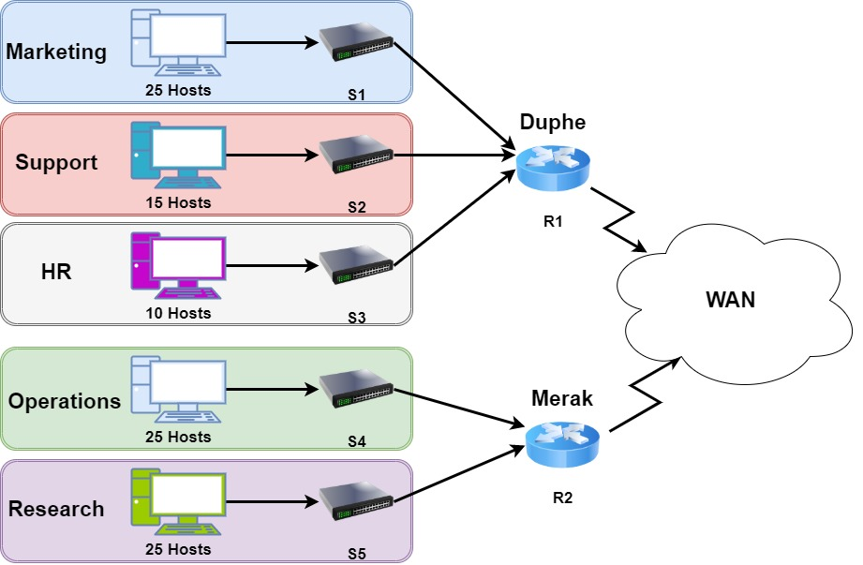

Answer the following questions:

1. Based on the topology, how many subnets are needed?

|  |
| --- |
| 5 |

2. How many bits must be borrowed to support the number of subnets in the topology?

|  |
| --- |
| 3 |

3. With the borrowed bits, how many subnets can be created?

|  |
| --- |
| 8 |

4. How many usable hosts per subnet can be assigned an IP address with the remaining bits?

|  |
| --- |
| 30 |

5. Calculate the binary values for the subnets.

|  |
| --- |
| 195.168.10.00000000 - 0 - 195.168.10.0/27 |
| 195.168.10.00100000 - 32 - 195.168.10.32/27 |
| 195.168.10.01000000 – 64 - 195.168.10.64/27 |
| 195.168.10.01100000 - 96 - 195.168.10.128/27 |
| 195.168.10.10000000 - 128 - 195.168.10.160/27 |
| 195.168.10.10100000 - 160 - 195.168.10.192/27 |
| 195.168.10.11000000 - 192 - 195.168.10.224/27 |
| 195.168.10.11100000 - 224 - 195.168.10.256/27 |

6. Calculate the binary and decimal value of the new subnet mask.

|  |  |
| --- | --- |
| Binary | 11111111.11111111.11111111.11100000 |
| Decimal | 255.255.255.224 |

7. Fill in the below table, listing the decimal value of all available subnets, the first and last usable host address, and the broadcast address.

|  |  |  |  |  |
| --- | --- | --- | --- | --- |
| Subnet | Subnet ID | First Usable Host Address | Last Usable Host Address | Broadcast Address |
| Marketing | 195.168.10.0 | 195.168.10.1 | 195.168.10.30 | 195.168.10.31 |
| Support | 195.168.10.32 | 195.168.10.33 | 195.168.10.62 | 195.168.10.63 |
| HR | 195.168.10.64 | 195.168.10.65 | 195.168.10.94 | 195.168.10.95 |
| Operations | 195.168.10.96 | 195.168.10.97 | 195.168.10.126 | 195.168.10.127 |
| Research | 195.168.10.128 | 195.168.10.129 | 195.168.10.158 | 195.168.10.159 |